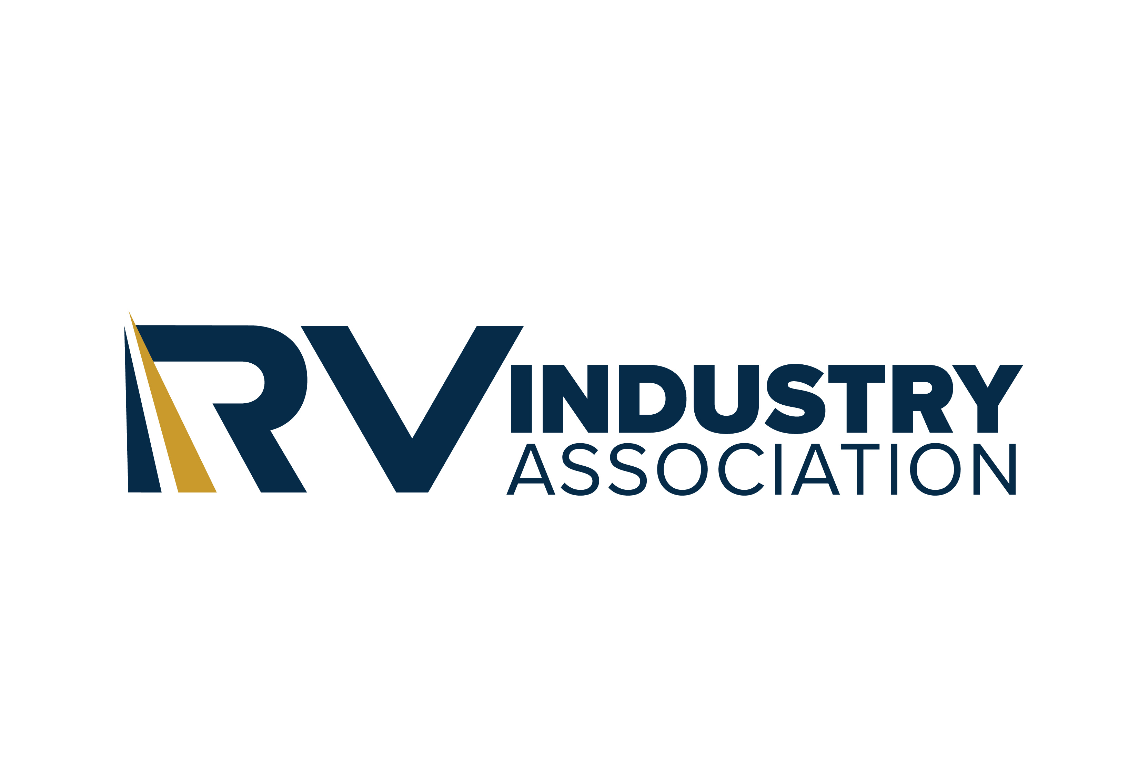

Testimony of the RV Industry Association before the Senate Committee on Tax, Business and Transportation on SB 287

Chairman Hamblen and members of the Committee, I am Michael Ochs, Director of Government Affairs for the RV Industry Association. I thank you for the opportunity to appear before you today on its behalf in strong support of SB 287, a bill to govern the relationship between manufacturers and dealers of recreation vehicles (“RVs”) in New Mexico.

The RV Industry Association is the national trade association which represents RV manufacturers and their component parts suppliers, who together build more than 98 percent of all RVs produced in the U.S. The Association is the unifying force for promoting safety and professionalism within the RV industry; and works with federal and state policymakers, as well as recognized national standards-setting bodies, to promote and protect the RV industry. Our members build RVs, such as motorhomes, truck campers, travel trailers, fifth-wheel trailers, folding camping trailers, and park model RVs.

According to the RVs Move America economic impact study, the total economic output of the RV industry in Indiana is $535 million.
- Manufacturers and suppliers = $42 million
- Sales and service = $261 million
- Campgrounds and travel = $232 million

There are approximately 516 RV-industry related businesses in the state, paying total taxes of $68 million. RV-related businesses pay more than $197 million in wages and are responsible for more than 3800 jobs in New Mexico.

The RV industry operates on a one-dealer-to-many manufacturers model with no true franchise relationship between parties in a manufacturer-dealer agreement, while the auto industry is typically one dealer to one manufacturer and is based on a true franchise model. However, we have a patchwork of laws across the country that create confusion on which part of what provision applies to which industry, and under what circumstances.

To fix this problem, and to address other structural problems in the law, the RV Industry Association is asking this Committee to support SB 287, to place the manufacturer-dealer relationship for RVs in a separate chapter of law. This legislation is the product of negotiation between the RV Industry Association and RV dealers in New Mexico, all of whom strongly support its approval. Passage of this legislation will strengthen the viability of the RV industry in Indiana to the state’s benefit and that of consumers, manufacturers, and dealers alike.

Consumers will benefit from the better relationship between RV manufacturers and dealers since the legislation will improve cooperation between the two on warranty matters, pre-delivery inspection, and other issues. Consumers will also benefit from a more stable environment, knowing that the dealer who sold them an RV will continue carrying those brands.

This bill would place the RV industry in a separate chapter from the auto industry, finally allowing these two industries to operate separately under law as they do in fact.

SB 287 is designed to be fair, reciprocal and reasonable to all stakeholders – and in the RV industry, that includes not only the dealer and the manufacturer, but also suppliers to manufacturers who provide a written warranty on their products directly to those who purchase and enjoy RVs. These suppliers must also treat dealers fairly under SB 287 in warranty matters – a major difference from the automobile industry.

SB 287 - An RV Specific manufacturer-dealer agreement law:
- Accommodates the RV industry’s unique “one-dealer-with-many-manufacturers” business model that is not based on a franchise structure; and
- Works best for the RV industry and the state – the RV industry will not be out of compliance with any inapplicable automobile franchise provisions the law might contain.

Key Points for State Legislators
- An RV Specific Model law negotiated between RVIA and the national RV Dealers Association in 2020, which forms the basis for SB 287, has been enacted in 21 States with no negative repercussions.
- RV specific laws slightly different from the Model Law have been enacted in another four States.
- Both RV manufacturers and RV dealers in the state are asking for this legislation and have agreed on the language to be included.
- The bill includes industry-approved definitions for all RV types for clarity.

Key Provisions for RV Dealers
- Warranty obligations would include original equipment manufacturers (OEMs) and suppliers of component parts and assemblies.
- Dealer-initiated termination of a manufacturer/dealer agreement – a common RV industry practice not often seen in the auto industry – is authorized by the bill.
- Multi-state dealers, like manufacturers, will benefit from consistent manufacturer-dealer laws across the states.

Key Provisions for RV Manufacturers and Suppliers
- Consistent laws around the country simplify business operations.
- A fair, reciprocal, reasonable law means dealer and manufacturer are treated equitably.
- Placing the RV industry in a separate chapter will avoid future conflict with auto franchise laws.

We urge all members of this Committee to vote “Yes” on this important legislation and advance SB 287 to the full Senate.

