Justification:
On March 7th the Diagnostic Port Ad Hoc Group met and resolved the outstanding request for further development.
The members voted to add the Molex Mini-Fit Jr style Pin & Socket 0.165” 4 pin connector to the options for the Service Port connector. Also, the Service Port location requirements were modified to include options in the immediate area of the entry door and/or labeling with a permanently affixed unit information sheet or equivalent documentation. The Official Business Post has been updated with changes.

Original Section:
2.2 Diagnostic Connector
A recreation vehicle equipped with a RV-C network shall be equipped with a standard connector specifically for the attachment of diagnostic tools. The connector shall be from the amp circular plastic connector (CPC) series, with 9 pins. A typical member designed for bulkhead mounting is Amp 206705-01 as shown in Figure 2.2. Any exact mechanic equivalent is acceptable.
Figure 2.2 — Diagnostic connector

Table 2.2 defines the pin assignments.
Table 2.2 — Pin assignment
Pin | Description
1 | Power (12 VDC). This may be tapped by the diagnostic tool.
2 | reserved
3 | reserved
4 | reserved
5 | Ground
6 | reserved
7 | Shield (optional)
8 | RV-C data (+) (CAN_H)
9 | RV-C data (-) (CAN-L)

Proposed Changes & Additions
Items marked in red will be removed and replaced with the text and sections below:

Table of Contents
2.2 Diagnostic Connector Service Port

Existing Section 2.2 text:
A recreation vehicle equipped with a RV-C network shall be equipped with a standard connector specifically for the attachment of diagnostic tools. The connector shall be from the amp circular plastic connector (CPC) series, with 9 pins. A typical member designed for bulkhead mounting is Amp 206705-01 as shown in Figure 2.2. Any exact mechanic equivalent is acceptable.
2.2 – Service Port
A recreation vehicle equipped with an RV-C network shall be equipped with a powered Service Port using specific connectors for the attachment of diagnostic tools that may also include capabilities of maintenance, configuration, and software updating. Service Ports are subject to the limitations described in section 2.1.

2.2.1 – Service Port Connectors

The connector shall be one of the following:

2.2.1.1 – Mini DIN-4 pin
A Mini DIN, 4 position receptacle, with keyed mating alignment type as shown in Figure 2.2.1.1. Figure 2.2.1.1 shows a panel mount version of the connector, but other mounting options are allowed. The pin-out assignment is shown in Table 2.2.
2.2.1.2 – Pin & Socket 0.165” 4 pin
A Pin & Socket 0.165” 4 position receptacle, as shown in Figure 2.1.4f. The pin-out assignment is shown in Table 2.2. Example connectors include Molex Mini-Fit Jr housing 39012041 and pin terminal 39000041. Any mechanically equivalent connector is acceptable.
2.2.1.3 – CPC 9 pin
A Circular Plastic Connector, 9 position receptacle, as shown in Figure 2.2.1.2. The pin-out assignment is shown in Table 2.2. Shown is a TE CPC 9, Series 1, Shell Size 13, (TE pn 206705-1). Any mechanically equivalent connector is acceptable.

2.2.2 - Service Port Location
The Service Port must be in one of the following locations, or, if not, information or a label similar to Figure 2.2.2 describing the location shall be provided in one of these locations and/or with a permanently affixed unit information sheet or equivalent documentation. The label may be of any type, but must be legible, with durability suitable for the location. Service Ports may be provided on devices mounted in these immediate areas if the connections conform to the bus topology described in section 2.1.
2.2.2.1 – Convenience Panel
The primary Service Port may be in the immediate area of the convenience panel or controls and information panels.
2.2.2.2 – Panel Board
The primary Service Port may be located in the immediate area of the main AC panel board.
2.2.2.3 – The primary Service Port may be located in the immediate area of the entry door.
2.2.3 – Service Port diagnostic tools
Diagnostic tools must comply with general RV-C device requirements.

Table 2.2 — RV-C Diagnostic Port Pin assignment
Pin# | Mini DIN-4 pin  Pin & Socket 0.165” 4 pin | CPC 9 pin
1 | CAN-H | PS+ (12Vdc)
2 | CAN-L | reserved
3 | PS- GND | reserved
4 | PS+ (12Vdc) | reserved
5 |  | PS- GND (or shield)
6 |  | reserved
7 |  | Shield (optional)
8 |  | CAN-H
9 |  | CAN-L

Figure 2.2.1.1 Mini DIN-4 pin RV-C Service Port Connector
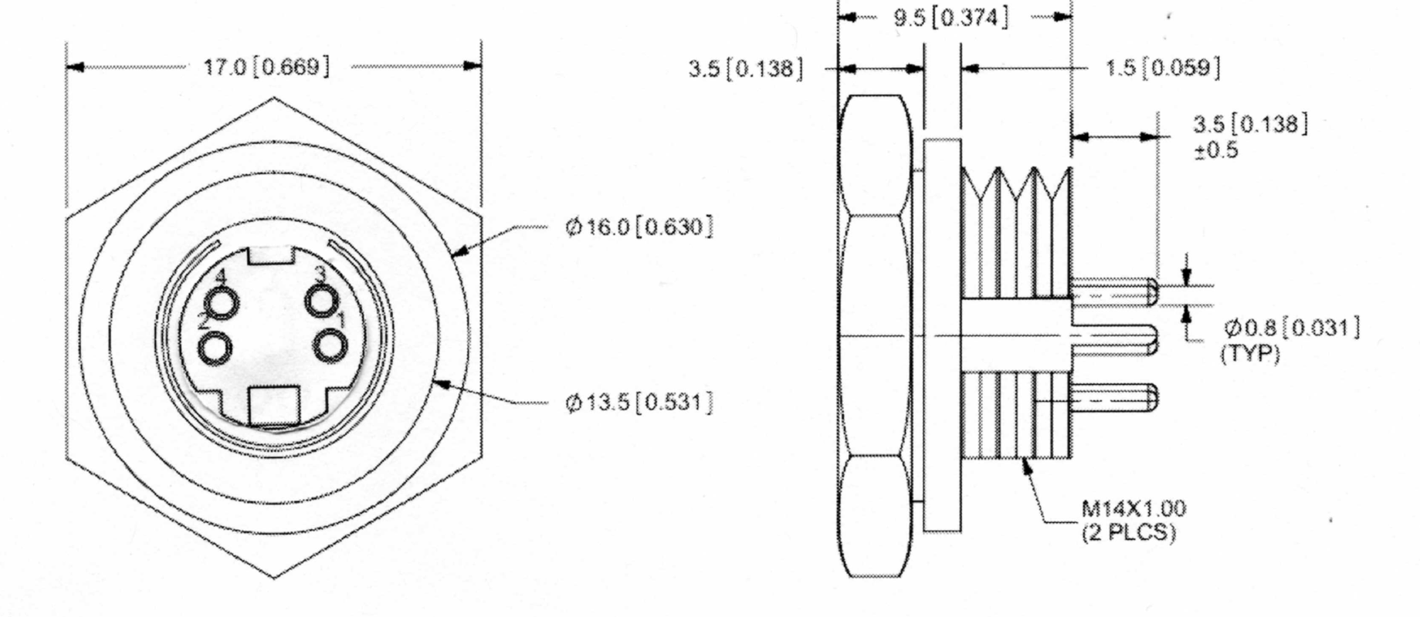

Figure 2.2.1.2 Circular 9-pin RV-C Service Port Connector
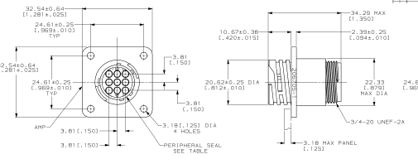

Figure 2.2.2 Example Service Port Label
RV-C Equipped
Service Port located under steering wheel column

